|  |  |  |  |  |  |  |  |  |  |  |
| --- | --- | --- | --- | --- | --- | --- | --- | --- | --- | --- |
|  |  | P1 (mbar) | P2 (mbar) | P3 (mbar) | P4 (mbar) | P5 (mbar) | T_mc (mK) | T_still (mK) | Still heater (mW) | Turbo pump |
| Optimal | Feb. 05, 2013 | 11 | 228 | 2.40E-2 | 1.50 | 90 | 10.0 | 963 | 5 | On |
| Before helium injection | Nov. 01, 2018 | 12 | 212 | 1.14E-1 | 0.77 | 132 | 59.0 | 930 | 5 | On |
| After 4He injection | Nov. 06, 2018 | 0 | 240 | 1.23E-2 | 0.84 | 166 | 59.0 | 928 | 5 | On |
| After 4He & 3He injection | Mar. 02, 2019 | 0 | 185 | 1.40E-2 | 0.90 | 86 | 38.7 | 767 | 0 | Off |
| Ursula (1) - July | -- | -3 | 121 | 3.10E-3 | 0.21 | 89 | 22.4 | -- | 0 | On? |
| Ursula (2) - Sept | -- | 62 | 252 | 3.00E-2 | 2.6 | 79 | 19.7 | -- | 10 | On? |
| Barry | -- | 0 | 168 | 1.30E-2 | 0.7 | 67 | 20.0 | -- | 0 | On? |
| Factory test | -- | 0 | 64 |  |  | 187 | 8.4 | 900 | 5 | On? |

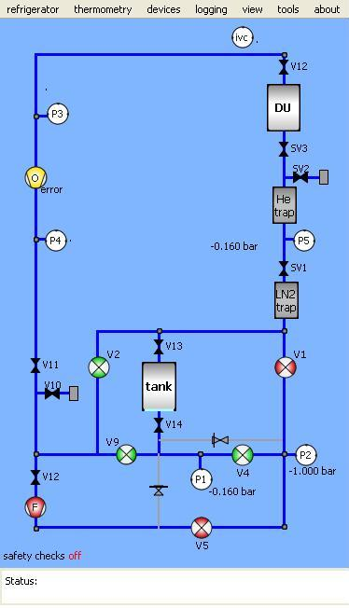

P1 = Tank Pressure

P2 = Forepump outlet pressure

P3 = Still pressure

P4 = Forepump inlet pressure

P5 = Condensing pressure

SV3 = Speedi valve on Insert condenser line

V12 = Gate valve on Insert Still pumping port

V11 = Angle valve on the back of Turbo Pump

V15 = Angle valve on Forepump Inlet

SV1 = Speedi valve on Nitrogen Cold trap outlet

V10 = Angle valve to get excess to system

V13 & V14 = Manual valves on Dump